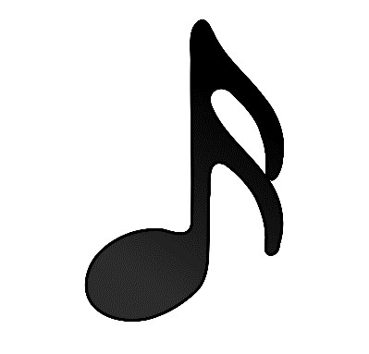  sixteenth note | beat
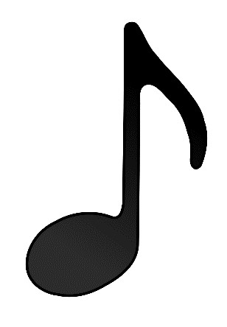  eighth note | beat
dotted eighth note | beat
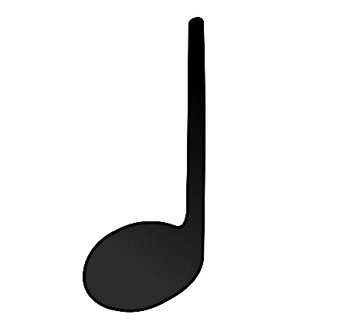  quarter note | 1 beat

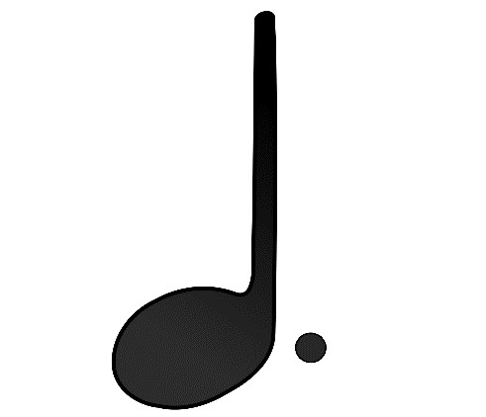  dotted quarter note | 1 beats
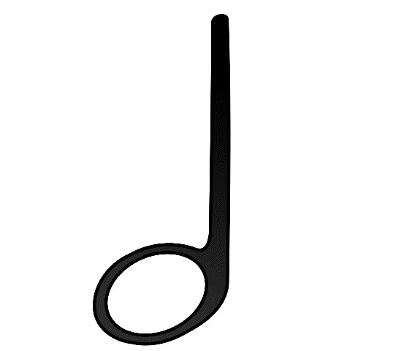  half note | 2 beats
dotted half note | 3 beats
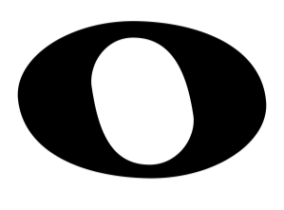  whole note | 4 beats

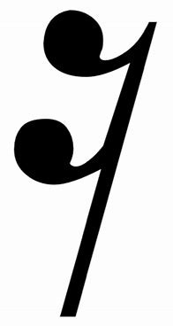  sixteenth rest | beat
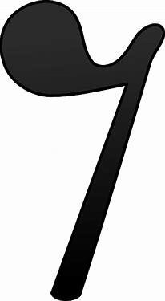  eighth rest | beat
dotted eighth rest | beat
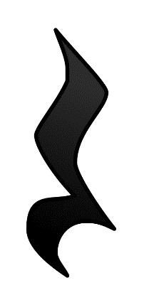  quarter rest | 1 beat

dotted quarter rest | 1 beats
Looks like a hat.  half rest | 2 beats
dotted half rest | 3 beats
Looks like a hole.  .  whole rest | 4 beats (or rest for an entire measure)

